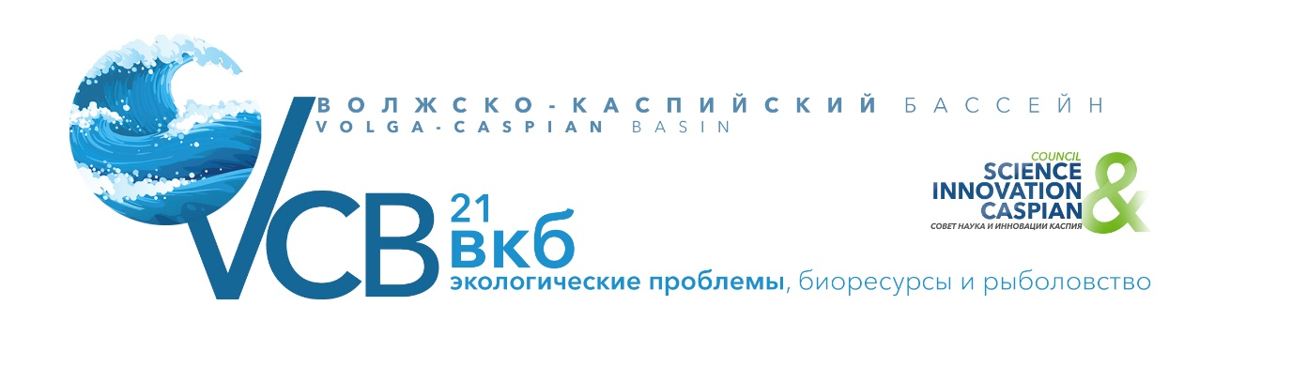

APPLICATION
for MEDIA participation in the International Conference
April 28-29, 2021, IPEE RAS
MEDIA Name/Organizations:
(Russian/English)
Postal address and code:
Last name, first name, patronymic of the participant:
(Russian/English)
Participant's position:
(Russian/English)

Contact information of the participant:
(tel., mobile. t., e-mail)
Contact person:
(phone, mobile, email)
Estimated equipment to be brought in (for full-time participation)

Date _____________ Signature__________ /__________________/

Please send your Application to the Organizing Committee
of the International Conference
by April 02, 2021 by e-mail: caspiancouncil@mail.ru, ndlevshina@mail.ru
Contact persons: Viktor Kovtun (+79161319059), Nina Levshina (+79168677462).
www.caspiansovet.ru

